**LAB CAT – 1**

Grihit Budhiraja

19BCE2141

**Code –**

#include <bits/stdc++.h>

using namespace ::std;

int main()

{

char ip[30],c;

cout<<"\nEnter the IP address: ";

gets(ip);

int i = 0,num = 0, j = 1;;

while (ip[i] != '.')

{

i++;

}

i--;

while (i >= 0)

{

num = num + (ip[i] - '0') * j;

j = j * 10;

i--;

}

if (num >=1 && num <= 126)

c = 'A';

else if (num >= 128 && num <= 191)

c = 'B';

else if (num >= 192 && num <= 223)

c = 'C';

else if (num >= 224 && num <= 239)

c = 'D';

else

c = 'E';

cout<<"\nThe class of the IP address "<<ip<<" is "<<c;

return 0;

}

**Outputs –**

**A)**

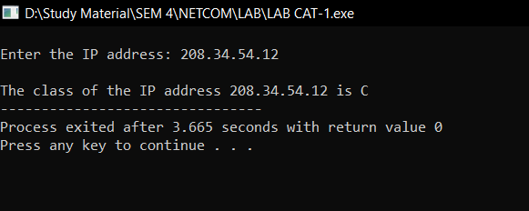

**B)**

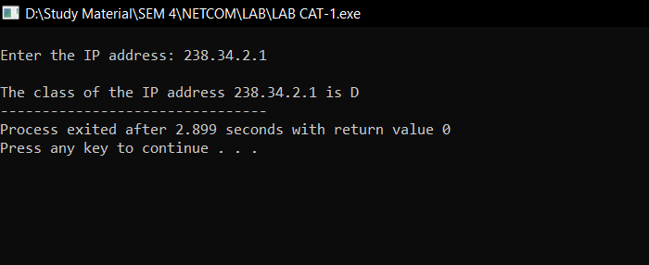

**C)**

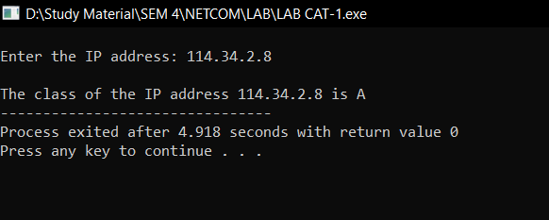

**D)**

